Shenzhen DOOGEE Hengtong Technology CO.,LTD

**EU DECLARATION OF CONFORMITY**

in accordance with

Annex VI of Directive 2014/53/EU of the European Parliament and of the Council

1. For the following Radio equipment: Tablet

Product name / Number (s): Tablet / T20Ultra, T20Ultra Pro, T20Ultra Plus, T20Ultra Max, T40 Pro, T40 Pro VIP Edition, T40 Ultra, T40 Max, T40S, T40SE, T40E, T40W, T40 Ultra VIP Edition, T40 Max VIP Edition, T40S VIP Edition, T40SE

VIP Edition, T40E VIP Edition, T40W VIP Edition

Tradename or Brand: DOOGEE

Software: N/A

Hardware number: N/A

1. Name and address of the manufacturer: B, 2/F, Building A4, Silicon Valley Power Digital Industrial Park, No. 22, Dafu Industrial Zone, Guanlan Aobei Community, Guanlan Street, Longhua New District, Shenzhen, Guangdong China Manufacturer: Shenzhen DOOGEE Hengtong Technology CO.,LTD
2. This declaration of conformity is issued under the sole responsibility of the Manufacturer.
3. Object of the declaration (identification of the radio equipment allowing traceability; it may include a colour image of sufficient clarity where necessary for the identification of the radio equipment):

PIFA Antenna; FM: Use earphone as Antenna

BT/Wi-Fi 2.4G: 1.63 dBi; Wi-Fi 5G: 0.84 dBi ; GPS: -0.48dBi

GSM900: -3.57dBi;DCS1800: -0.98 dBi; WCDMA Band Ⅰ: -2.27dBi ;Band Ⅷ: -3.57dBi;

LTE Band 1: -2.27Bi; Band 3: -0.98dBi; Band 7: -2.45dBi; Band 8: -3.57dBi; Band 20: -2.9dBi; Band 28: -2.9dBi;

Band 38: -2.73dBi; Band 40: -3.19dBi; Band 41: -2.44dBi

# Adapter:

Model: HJ-FC017K7-EU

Input: 100-240V~50/60Hz 0.6A Output: 5.0V 2.0A or 7.0V 2.0A



or 9.0V 2.0A or 12.0V 2.0A (24.0W)



Manufacturer: Shenzhen Huajin Electronics Co., Ltd

Rechargeable Li-ion Battery; Model: BAT23P2T10800; Specification: DC 3.85V, 10800mAh, 41.58Wh; Manufacturer: Shenzhen Uteli Energy Co., LTD

USB Cable: 150cm;

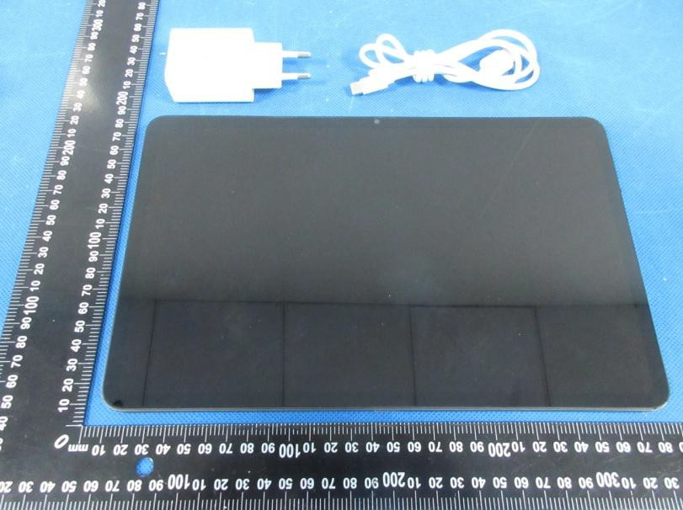

1. The object of the declaration described above is in conformity with the relevant Union harmonization legislation: Directive 2014/53/EU (RED)
2. References to the relevant harmonized standards used or references to the other technical specifications in relation to which conformity is declared:

|  |  |
| --- | --- |
| Referenced Standards: | |
| Article 3.2Radio: | ETSI EN 301 511 V12.5.1 (2017-03);  ETSI EN 301 908-1 V13.1.1 (2019-11);  ETSI EN 301 908-2 V13.1.1 (2020-06);  ETSI EN 301 908-13 V13.1.1 (2019-11);  ETSI EN 300 328 V2.2.2 (2019-07);  ETSI EN 301 893 V2.1.1 (2017-05);  ETSI EN 300 440 V2.2.1 (2018-07)  ETSI EN 303 413 V1.2.1 (2021-04);  ETSI EN 303 345-1 V1.1.1 (2019-06);  ETSI EN 303 345-3 V1.1.1 (2021-06) |
| Article 3.1EMC: | ETSI EN 301 489-1 V2.2.3 (2019-11) |
| ETSI EN 301 489-3 V2.1.1 (2019-03) |
| ETSI EN 301 489-17 V3.2.4 (2020-09) |
| ETSI EN 301 489-19 V2.1.1 (2019-04) |
| ETSI EN 301 489-52 V1.2.1 (2021-11) |
| EN 55032:2015+A1:2020 |
| EN 55035:2017+A11:2020 |
| EN IEC 61000-3-2:2019+A1:2021 |
| EN 61000-3-3:2013+A2:2021 |
| Article 3.1a Safety: | EN IEC 62368-1:2020+A11:2020 |
| Article 3.1a Health | EN 50566:2017; |
| EN 62209-2:2010; |
| EN 62479:2010; |

1. Notified Body Name: Eurofins Electrical and Electronic Testing NA, Inc.

Notified Body Number: 0980

Notified Body Assessment Performed: Module B/C on Article 3.1a, 3.1b, 3.2 and 3.3

EU-type examination certificate number: 3316-08-2024-240566

1. Where applicable, description of accessories and components, including software, which allow the radio equipment to operate as intended and covered by the EU declaration of conformity: User instructions are provided in the User Manual. The Software and Hardware versions are specified above.
2. Additional information:

Referring to Article 10.2 of the Directive, this equipment is so constructed that it can be operated in all Member States, without infringing applicable requirements on the use of radio spectrum.

Referring to Article 10.10 of the Directive, there are no restrictions on putting this equipment intoservice or of

requirements for authorisation of use. Please refer to the User Manual for details. On behalf of:

address: B, 2/F, Building A4, Silicon Valley Power Digital Industrial Park, No. 22, Dafu Industrial Zone, Guanlan Aobei Community, Guanlan Street, Longhua New District, Shenzhen, Guangdong China

Manufacturer: Shenzhen DOOGEE Hengtong Technology CO.,LTD

(place and date of issue): 2024/08/02

(name, function): ………… Fangtang……… (signature): ………………… …

